Hong Kong Institute of Information Technology
IT114105 HD in Software Engineering

ITP3914 Programming
Topic 1: Basic Programming Concepts

Lab 1 – Program Design
Intended Learning Outcomes
Upon completion of this tutorial/lab, you should be able to:
- Identify inputs, outputs, and processing components from a problem description.
- Work out solution steps for the defined problem with sequence, selection and repetition control structures.

Exercise 1
List the seven basic steps in computer program development.
- Define the problem
- Outline the solution
- Turn the outline into steps for solving the problem
- Test the steps for correctness
- Code the steps into a targeted programming language
- Run the program on a computer
- Document and maintain the program

Exercise 2
What are the inputs and outputs of the problems below?
(a) Calculating the area of a triangle
Input: ___base, height__________________________________
Output: __triangle area___________________________________

(b) Calculating the solution(s) of a quadratic equation 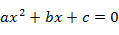
Input: coefficients (a, b, c) of the quadratic equation
Output: solutions (roots) of the quadratic equation OR message “no solution”
(c) Measuring the distance of two cities on Earth
Input: ___longitude and latitude of the two cities
Output: distance of two cities_____________________________________

Exercise 3
Suggest suitable names for variables storing the data below.
(a) A student’s English name
___studENname____________________
(b) The examination mark of a student in the module “Programming”.
___Prog_ExMark____________________
(c) A student’s ID number
____studID___________________
(d) Number of items in a shopping cart
______numInCart _________________

Exercise 4
Draw a flow chart to illustrate how the problem below can be solved. Specify clearly the input, process, and output steps with correct flowchart symbols.
PROBLEM: Convert a length in inches to centimeters (1 inch = 2.54 cm).
ANSWER:
Start
Input inches

Length cm =
Length inches*2.54

Output length

End

Exercise 5
Draw a flow chart to illustrate how the problem below can be solved. Specify clearly the input, process, and output steps with correct flowchart symbols.
PROBLEM: In New York City (NYC), even numbered streets are east-bound, odd numbered streets are west-bound. Given a street number of a street in NYC, decide the direction of the street, either east-bound or west-bound. Print a message on screen to tell the user the direction.

ANSWER:
true
Start
Input num street
Num %2 == 0
West-bound
East-bound
End
Proc. Num = odd
Proc. Num = even
false

Exercise 6
Draw a flow chart to illustrate how the problem below can be solved. Specify clearly the input, process, and output steps with correct flowchart symbols.
PROBLEM: Calculate the parking fee based on the vehicle type and the hours a vehicle spent in a car park. The parking fee is charged according to the table below.
Vehicle Type | Hourly Rate ($ per hour)
Private Car | 15
Bus | 35
Truck | 50
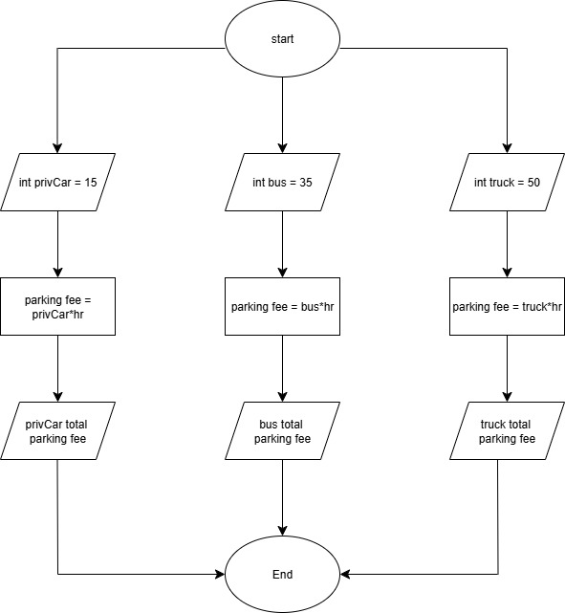

Exercise 7
Draw a flow chart to illustrate how the problem below can be solved. Specify clearly the input, process, and output steps with correct flowchart symbols.
PROBLEM: Input an examination mark (0-100) and determine the grade (A to F) obtained according to the table below.
Mark | 0-59 | 60-69 | 70-79 | 80-89 | otherwise
Grade | F | D | C | B | A
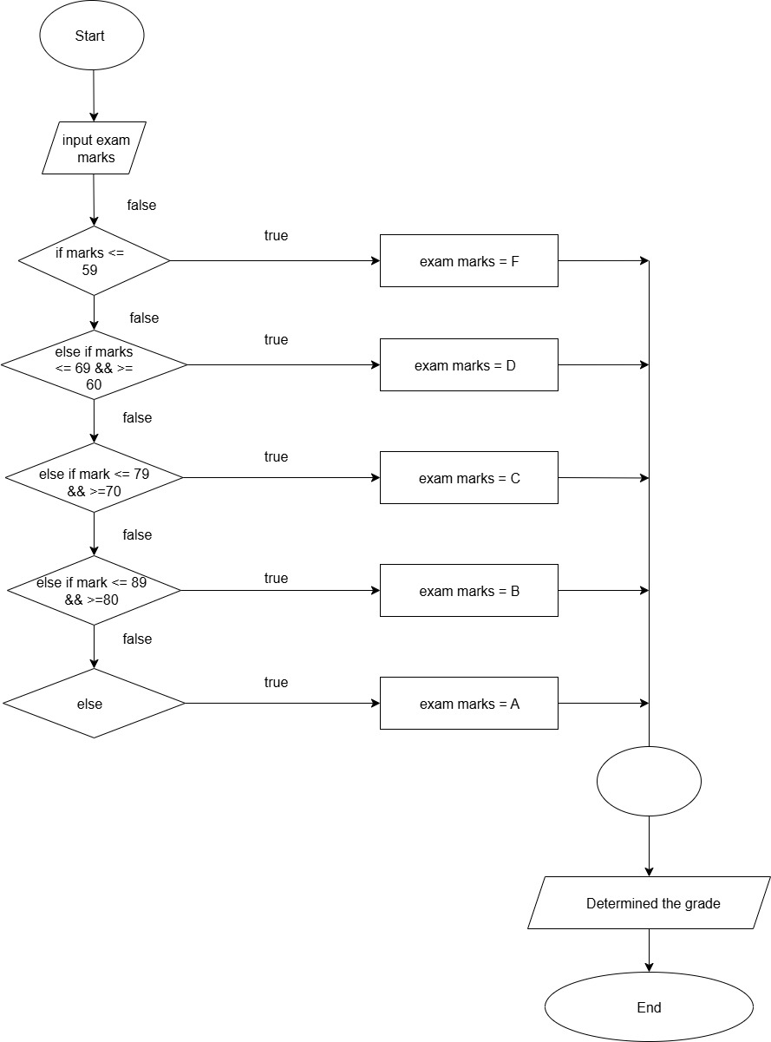

Exercise 8
Draw a flow chart to illustrate how the problem below can be solved. Specify clearly the input, process, and output steps with correct flowchart symbols.
PROBLEM: As the user to input a positive integer value (n) and then displays ‘*’ times on the screen. A sample execution is shown below.
Please input a positive integer: 5
*****
HINT: Use the repetition construct. At each iteration, you need to determine if enough ‘*’ have been printed.
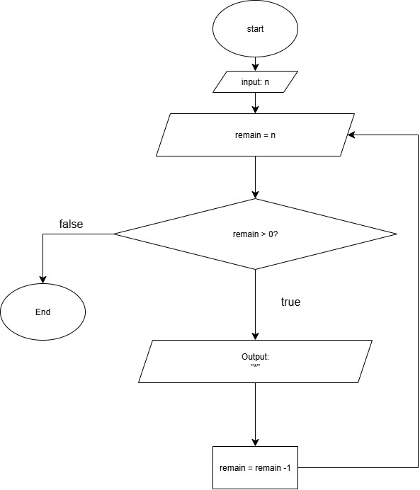

Exercise 9
Draw a flow chart to illustrate how the problem below can be solved. Specify clearly the input, process, and output steps with correct flowchart symbols.
PROBLEM: Given the width and length of a piece of rectangular paper, determine the maximum number of small-size rectangular photos that can be printed on it. The photos can be arranged either in portrait or landscape.

Portrait arrangement:
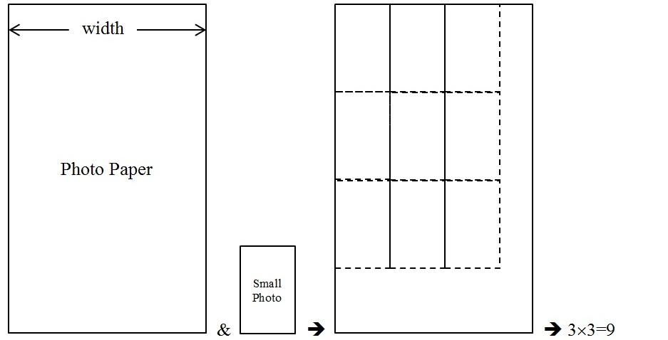

Landscape arrangement:
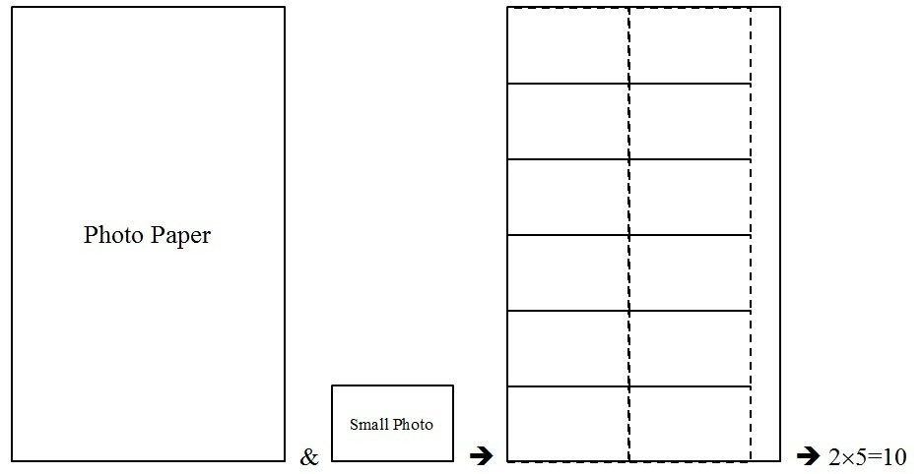

END.

